# Information Visualization

# CHECKPOINT III: Visualization Sketch

G14-A

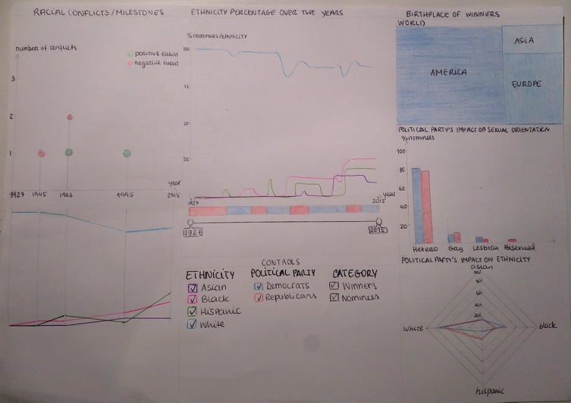**1. Overview**

Figure 1- A overview of our visualization.(Replaced Choropleth Map with Treemap and added titles

to Idioms)

**2. Visual Encodings**

In this visualization the user will be able to choose four variables that affect all idioms. The **Time** (by selecting an interval on a timeline), the **Political Party** **in Power** and the **Ethnicity** and the **Winners/Nominees** (through lists) and see how these variables affect the nominees/winners of the Oscars ceremony. As seen in the sketch above, the chosen idioms are:

* **Line chart** – chosen to represent how the percentage of nominees per ethnicity changes over the years. It has a political timeline below (blue and red line), which informs on which political party was in power in which year range.
  + 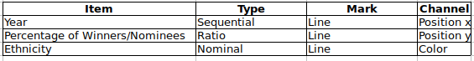Interaction: choose a time interval, directly on the map or in the timeline below. This will affect all the other idioms, which will only show information regarding the selected time span.
* **Treemap** – chosen to represent how the percentage of winners per country changes with time and political party in power. (Redone table)



* + Interaction: Hover on each country to find the exact percentage of winners born in that country.
* **Grouped bars** – chosen to represent the percentage of winners / nominees of each sexual orientation changes with the political party in power. The 2 colours that fill the bars area correlate the orientation of the nominees/winners with the political party in power at the time.
  + 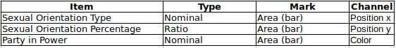Interaction: Hover on each bar to find the exact percentage of winners / nominees with that sexual orientation. Clicking on one of the colors will change all the other idioms except for the line chart, in order to only show data for the years of the selected time span when the chosen political party was in power.
* 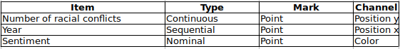**Lollipop** – this is an adaptation of an idiom found in a D3 gallery, chosen to represent the number of racial conflicts / milestones per year. Each point represents an event, and the color represents if it was positive (green) or negative (red).
  + Interaction: the beginning and end of x axis is determined by the time span selected in the line chart. Hover on each point to see a description of the racial conflict / milestone.
* 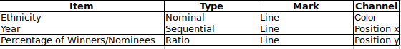**Slopegraph** – This works through a synergy with the Lollipop by showing how the ethnicity of the Oscar nominees/winners varies according to the black history milestones happening at the time. Each vertical line represents a year where a racial conflict / milestone occurred and each different colored line represents an ethnicity.
  + Interaction: Hover on each line to see the value of the y axis (percentage of winners / nominees in that year).
* 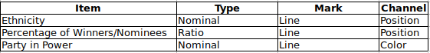**Star plot** – represents an ethnicity on each vertice, and each line represents one political party.
  + Interaction: Click on an ethnicity on each vertice of the star plot to change the slopegraph (emphasize the line corresponding to that ethnicity), the choropleth map (only show birthplace of people with that ethnicity) and the grouped bar chart (only show sexual orientation of people with that ethnicity). Clicking on one of the colored lines (political parties) will change all the other idioms except for the line chart, in order to only show data for the years of the selected time span when the chosen political party was in power.

**3. Answering the questions**

* **Question 1** can be answered by selecting the year range on the line chart and seeing how each political party affects the percentage of winners / nominees of each sexual orientation in the grouped bar chart.
* **Question 2** can be answered by selecting the year range on the line chart and then selecting one of the political parties from the starplot and seeing the map change. By visualizing the different areas (continents/countries), one is able to tell which continents/countries had a greater/smaller representation of winners on a given time interval. Below is a storyboard representing the interaction necessary to answer this question. Note: in the last square, the racial conflict disappears because it is assumed it occurred when the other party was in power.

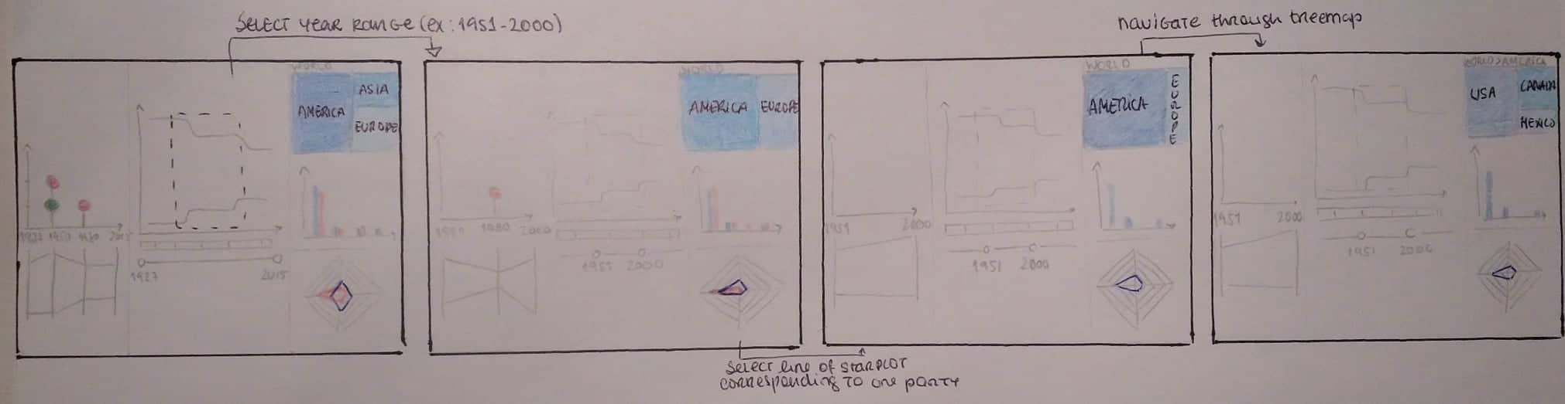(New Storyboard)

* **Question 3** can be answered by selecting the year range on the line chart and looking at the slopegraph to see a more direct comparison. To reduce the number of ethnicities seen in the slopegraph, the ethnicities can be selected by clicking on the vertices of the star plot.
* **Question 4** can be answered by selecting the year range on the line chart and comparing the lines of each political party per ethnicity.
* **Question 5** can be answered by selecting the year range on the line chart and looking at the lollipop and the slopegraph, which are directly connected. If a milestone is selected, its description is shown on the Lollipop idiom.

Notes:

* While preparing this checkpoint, we noticed that our 6th question was to specific and didn’t match the rest of the questions, so we discarded it.
* Since we are aware of missed opportunities, we will change our previous data in order to answer some new questions which we already considered on this delivery. For example, the birthplace will be affected not only by political party, as we had initially envisioned, but also by year range and ethnicity.